Programming@FMS
Teacher Edition
Programming – unit 2

Objectives

The students will get more familiar with Scratch.

They will learn about and apply the "basic building blocks" of programs (sequence, repetition, conditional execution, variables).

The students shall understand the concept of turtle graphics for the exploratory learning in primary school.

They will deal with the programming of turtle graphics by means of a concrete example.

Introduction

From unit 1 of the "programming" course, the students of ‹Specialised Upper Secondary School - Occupational field of education› are familiar with programming as a process for formulating and implementing computer-based solutions to problems. They are familiar with basic concepts of programming (methodical approach, object and event orientation, process communication).

The example the students will work on in unit 2 of this programming course is a potential lesson in primary school (according to the Swiss curriculum "Lehrplan 21" around the end of grade 4). It has two main focuses.

The concept of the turtle graphic by Seymour Papert (https://de.wikipedia.org/wiki/Seymour_Papert) forms one focus. The other one is learning and applying the "basic building blocks" of programs (sequence, repetition, conditional execution, variable).

Programming for children in primary school can be designed in another way than a programming class in high school. With turtle graphics, primary school children can experiment and immediately see on the screen whether they are correct in their reasoning. If not, they adjust their "program" and observe and reflect on the changes brought about. The students should get to know the idea of turtle graphics by Seymour Papert, so that they can later use programming as a meaningful tool for exploratory learning as teachers in primary school.

The introduction also provides a first look at the concept of turtle graphics.
With these two focal points, unit 2 of the programming course becomes a nesting of two distinct sequences of lessons. In order to enable the students to recognise the intention behind this nesting, they may need support.

Example of a possible lesson with turtle graphics

The students are asked to assume that they have to deal with the topic "regular polygons" in the primary school. They shall give the primary pupils an exploratory learning task with turtle graphics in Scratch.

The students can access the template for the task at https://scratch.mit.edu/projects/698418539

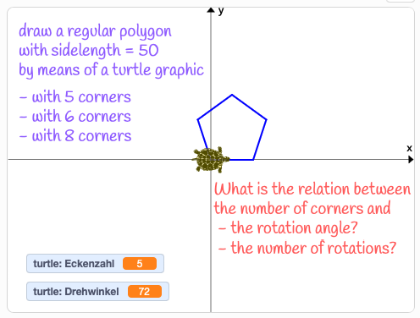

Next, the future teachers are asked to put themselves in the pupil's place and program the turtle graphic on their own.

The instructions for the students are designed in the same way as they could be given to the pupils in primary school. Two imaginary students, Alice and Bob, give the necessary explanations in the form of a dialogue.

The "basic building blocks" of programs

The students have programmed the turtle graphic and experienced how primary school pupils can use the computer for exploratory learning with Scratch.

The students should now switch back to their role as a future teacher.

The turtle graphic that the students have programmed is now used as a basis for learning about and applying the "basic building blocks" of programs: sequence, repetition, conditional execution, variable.

Reflection

Discovery learning with turtle graphics is different from programming an application to solve a problem.

How would you describe this difference?

Sample solution: https://scratch.mit.edu/projects/671362882

