1a)
$$f\left(-x\right)=\frac{x^{3}-8x}{x^{2}-9}=-\frac{-x^{3}+8x}{x^{2}-9}=-f(x)$$
b)
$$\left(x^{3}-8x\right):\left(x^{2}-9\right)=-x+\frac{x}{x^{2}-9}$$
$$\lim_{x→∞}{\frac{x}{x^{2}-9}}=0$$
c)
x(x²+8)=0 x=0 f(0)=0
x²=-8
X(0|0)
d)
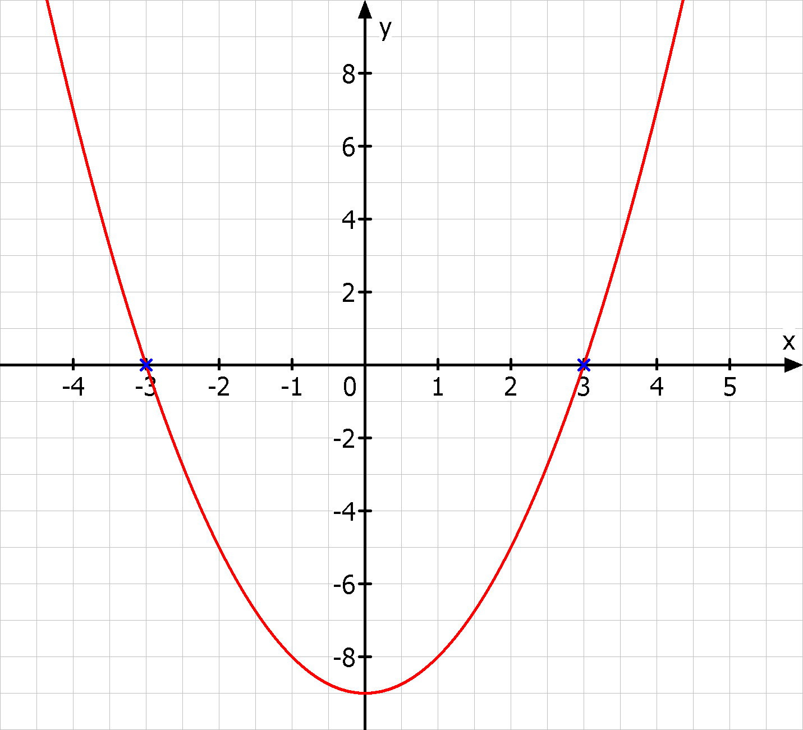
x=-3 x=3
Zähler: 54 Zähler: -3
VZW +- VZW +-
e)
$$f^{'}\left(x\right)=\frac{\left(-3x^{2}+8\right)\left(x^{2}-9\right)-2x(-x^{3}+8x)}{{\left(x^{2}-9\right)}^{2}}=\frac{-3x^{4}+27x^{2}+8x^{2}-72+2x^{4}-16x^{2}}{{\left(x^{2}-9\right)}^{2}}=\frac{-x^{4}+19x^{2}-72}{{\left(x^{2}-9\right)}^{2}}$$
$$f^{''}\left(x\right)=\frac{\left(-4x^{3}+38x\right){\left(x^{2}-9\right)}^{2}-4x\left(x^{2}-9\right)\left(-x^{4}+19x^{2}-72\right)}{{\left(x^{2}-9\right)}^{4}}=\frac{-4x^{5}+38x^{3}+36x^{3}-342x+4x^{5}-76x^{3}+288x}{{\left(x^{2}-9\right)}^{3}}$$
$$=\frac{-2x^{3}-54}{{\left(x^{2}-9\right)}^{3}}=-2x\frac{\left(x^{2}+27\right)}{{\left(x^{2}-9\right)}^{3}}$$
-x⁴+19x-72=0 x²=z
z²-19x+72=0
$$z=9,5±\sqrt{{9,5}^{2}-72}$$
z₁=13,77 z₂=5,23
x=-2,29 x=2,29 x=-3,71 x=3,71

$$f^{''}\left(-2,29\right)=2∙2,29\frac{{\left(-2,29\right)}^{2}+27}{{\left({2,29}^{2}-9\right)}^{3}}=-2,79$$
$$f\left(-2,29\right)=\frac{-{\left(-2,29\right)}^{3}-8∙2,29}{{2,29}^{2}-9}=1,68$$
H₁(-2,29|1,68)
$$f^{''}\left(2,29\right)=-2∙2,29\frac{{\left(2,29\right)}^{2}+27}{{\left({2,29}^{2}-9\right)}^{3}}=-2,79$$
$$f\left(2,29\right)=\frac{-{2,29}^{3}+8∙2,29}{{2,29}^{2}-9}=-1,68$$
T₁(2,29|-1,68)
$$f^{''}\left(-3,71\right)=2∙3,71\frac{{\left(-3,71\right)}^{2}+27}{\left({3,71}^{2}-9\right)}=63,49$$
$$f\left(-3,71\right)=\frac{-{\left(-3,71\right)}^{3}-8∙3,71}{{3,71}^{2}-9}=4,49$$
T₂(-3,71|4,49)
$$f^{''}\left(3,71\right)=-2∙3,71\frac{{3,71}^{2}+27}{\left({3,71}^{2}-9\right)}=-63,49$$
$$f\left(3,71\right)=\frac{-{3,71}^{3}+8∙3,71}{{3,71}^{2}-9}=-4,49$$
H₂(3,71|-4,49)

