Programming@FMS
Student Edition
Programming – unit 2

Objectives

You will continue to familiarise with Scratch.

You will learn and apply the "basic building blocks" of programs (sequence, repetition, conditional execution, variable).

You shall understand the concept of turtle graphics for exploratory learning in primary school.

You will deal with the programming of turtle graphics using a concrete example.

Introduction

In Part 1, you learned about programming as a process for formulating and realising computer-based solutions to problems.

Even though the example was still quite simple, you were able to familiarise with basic programming concepts (methodical approach, object and event orientation, process communication) by means of a matchstick puzzle.

In primary school, programming can support children in exploratory learning. In the seventies of the 20th century already, Seymour Papert dealt with the question of how computers can be used meaningfully in the primary school classroom and how, in particular, children could be introduced to programming in a way that is suitable for them (https://en.wikipedia.org/wiki/Seymour_Papert). In addition to numerous basic works, he developed the programming language "Logo" for this purpose.

Logo supports the idea of turtle graphics. Children can use Logo's commands (walk a certain number of steps, rotate clockwise a certain number of degrees, etc.) to control a pen (represented as a turtle) on the screen and use it to draw any forms they want. This approach allows them to independently and creatively seek, reflect and discuss solutions to mathematical and geometric problems.

Table 1: The main commands for turtle graphics in Logo
Walk a certain number of steps | FORWARD no. of steps
Rotate clockwise a certain number of degrees | RIGHT angle
Rotate counterclockwise a certain number of degrees | LEFT angle
Delete the drawing area | CLEARSCREEN
Put the pen down on the drawing area | PENDOWN
Hebe den Zeichenstift an | PENUP

The commands for turtle graphics can also be found in Scratch.
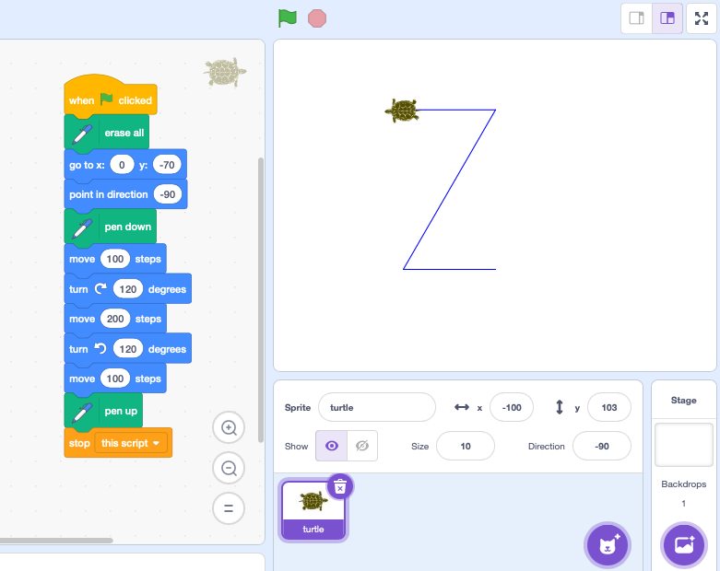Fig. 1: Turtle graphic in Scratch

Primary school pupils can experiment with these simple commands and immediately see on the screen whether they are correct in their reasoning. If not, they adjust the commands. Then, they observe and reflect on the changes that have been made.

The following example of a possible lesson in primary school pursues three goals:
- to know and understand the idea of turtle graphics
- to understand and apply the "basic building blocks" of programs (sequence, repetition, conditional execution, variable)
- to get more familiar with Scratch

The example is anchored in the Swiss curriculum "Lehrplan 21" at the end of the 2nd cycle in the subject Mathematics -> Shape and Space -> Exploring and Reasoning.

Example of a possible lesson with turtle graphic

Assume that you have to deal with the topic "regular polygons" in primary school. (Regular polygons are geometric shapes whose sides are all of the same length and where all interior angles are equal).

Your primary school pupils already know the equilateral triangle and the square. They should now explore the common properties of regular polygons (equilateral triangle, square, pentagon, hexagon, octagon, decagon, etc.) and formulate in their own words the relationship between the number of sides and the magnitude of the interior angle.

Also, assume that your students are already familiar with drawing turtle graphics in Scratch. You give the students the task directly in Scratch.

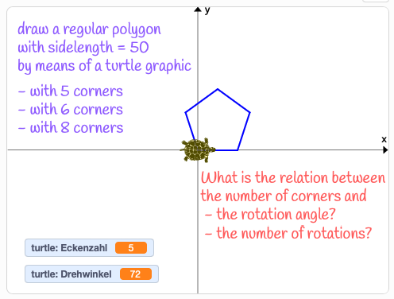Fig. 2: Discovering commmon properties of regular polygons with turtle graphic
You can find the template for this task on the Scratch platform: https://scratch.mit.edu/projects/698418539

Now try to put yourself in the student's place and program the turtle graphic on your own. Let «Alice» and «Bob» be your classmates.

Alice and Bob discover the properties of regular polygons

⇨ Draw an equilateral triangle with the side length of 50 (units).

⇨ Then draw a square with sides of the length of 50 (units).
What for?

In order to discover common properties of an equilateral triangle, a square, as well as other equilateral polygons.
What commands help us to do this?
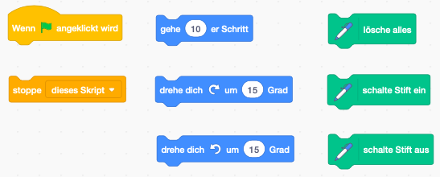

⇨ By how many degrees must the turtle rotate when drawing the triangle?

⇨ And by how many degrees when drawing the square?

form | Number of corners | Rotation angle in degrees
triangle | 3
square | 4
Ok, did it.
⇨ Now formulate the relationship between the number of corners and the angle of rotation.

Rotation angle= __________________________
Ooh! Can you give me a hint?
For the triangle and the square, multiply the angle of rotation by the number of corners.
Ah! Now it's clear.

⇨ How large must the angle of rotation be for a regular pentagon?

⇨ Try it out.

⇨ The interior angles of regular polygons measure 180° - exterior angles (rotation angles).

⇨ What is the interior angle of a regular pentagon?

The "basic building blocks" of programs

Now switch back to your role as a future teacher.

The turtle graphic you programmed will now serve as the basis for learning about and applying the "basic building blocks" of programs: sequence, repetition, conditional execution, variable.

Sequence
Perhaps (probably) you simply strung together the commands to draw the polygons. Commands that are strung together form a sequence.

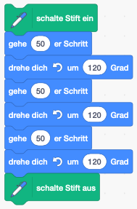Fig. 3: Sequence

Repetition
Instead of arranging commands in a sequence one after another, similar command sequences can be executed repeatedly in a loop. The command for repetition can be found in the block "
Control".
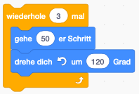Fig. 4: Repetition
⇨ In your program, summarise the consecutive commands for drawing the individual sides of the polygon with a repetition. The program becomes easier to read (the number of repetitions corresponds to the number of corners of the polygon).

Variables
Your program (probably) draws a very specific polygon. The number of corners in this case is fixed with the number of repetitions of the commands for drawing the individual sides (e.g. 3 for a triangle).
You could draw any regular polygons with your program, if you programmed the number of repetitions not with a fixed number (with a constant), but using a placeholder (a variable). Before the repetition, you would then simply have to assign the desired number of corners to the variable.
Variables (placeholders) have to be created. You have to give the variable a name and specify whether the variable should be available in the whole program (i.e. for all characters) or only in the scripts of the character in question.

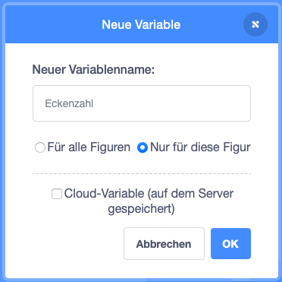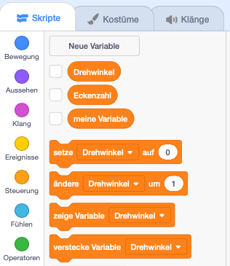Fig. 5: Creating a new variable
For assigning values (numeric values, strings) to variables, Scratch provides the command "Set {variable name} to {value or variable name}".

Fig. 6: Assigning a value to a variable

If the number of repetitions is no longer fixed with a constant value but can be changed with a variable, it must also be possible to change the angle of rotation accordingly. A second variable is therefore necessary.

⇨ Create two variables for your object (the character, the turtle). Name the variables "Number of Corners" and "Angle of Rotation" respectively.
Assign a value to the variable "Number of Corners" in your script (e.g. 8) and replace the fixed numerical value for the repetitions with the variable.
Assign the variable "Angle of Rotation" the appropriate value (360/"Number of Corners"; you discovered this relationship yourself with the turtle graphic). Then replace the fixed numerical value for the angle of rotation with the variable in the script.
The program should now draw the corresponding polygon.

Conditional execution
The larger the number of corners (the value of the variable), the larger the drawing of the polygon on the stage. For values greater than 10, the entire polygon is no longer visible.
To keep the drawing of the polygon completely visible, the polygon may only be drawn if the number of corners (the value of the variable in question) is less than 11.
To make the execution of a script block dependent on a condition, Scratch provides the command "If {condition met}, Then ..."
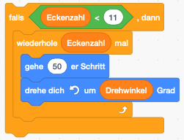Fig. 7: Conditional execution of a script block
Refine your program so that the polygon is not drawn if the number of corners is greater than 10.

Interaction
Your program would be more flexible if not only the programmer, but also the user could enter the number of corners.
A query of the number of corners is possible in Scratch with the command "Ask ″text″ and Wait". The input of the user is assigned by Scratch to the predefined variable "Answer".
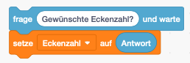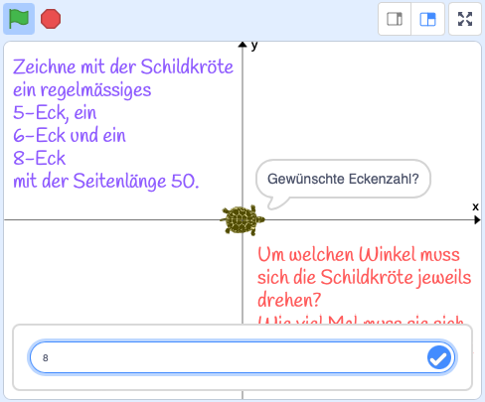
Fig. 8: Interaktion mit der Nutzer:in
Add a query for the number of corners to your program.
Test whether a polygon is drawn when the user enters a number of corners greater than 10.

Refine your program in such a way that when a number of corners greater than 10 is entered, a suitable operating note is displayed on the stage. (It would also make sense to display the hint before the input and to display an error message when entering a number of corners greater than 10).

Reflection

Exploratory learning with turtle graphics is different from programming an application to solve a problem.

How would you describe this difference?

