Programming@FMS

Programming course

Disposition
(Explanations of the objectives and structure of the programming course)

Programming at the ‹Specialised upper secondary school - occupational field of education›

This course was developed for students of the Swiss specialised upper secondary schools in the occupational field of education (=pedagogy), subsequently abbreviated as «SSC-P».

Programming is an activity that results in a computer program. The fascinating thing about it is the variety of different tasks that can be solved with such programs.

Why should future teachers learn how to program?

There are numerous sources that provide answers to this question. E.g. "Programming [is] as important as writing and reading.", "Every child should [...] have programmed once in his school career. Through programming, children acquire important skills for the future, such as creative and critical thinking, teamwork and much more.", "Programming is fun, promotes logical thinking, strengthens creativity and the ‹we-feeling›."

Beat Döbeli Honegger (Department of Media and Computer Science at the Lucerne University of Teacher Education) gives a more differentiated answer in his article "Warum Informatik in der Schule?" by declaring computer science as part of general education with nine arguments:
  - Argument 1: constructionism ("The computer as a pupil")
  - Argument 2: science ("Computer science belongs to general education since computer science has brought a third pillar to science through simulation.")
  - Argument 3: object of thought ("The computer as an object of thought")
  - Argument 4: problem solving ("Knowlegde about computer science also helps to solve problems outside of computer science.")
  - Argument 5: explanation of the world ("In order to understand and explain today's information society, knowledge of computer science is necessary.")
  - Argument 6: conceptual knowledge ("Knowledge of computer science helps to better understand the use of ICT.")
  - Argument 7: work technique ("Computer science can be used to practice precise planning, working, and communicating as part of a team.")
  - Argument 8: motivation/interest ("With computer science, students interested in technology can be engaged.")
  - Argument 9: career choice

Programming is an aspect of computer science. The programming course at SSC-P is limited to the following objectives:

  - The students of ‹Specialised Upper Secondary School - Occupational field of education› will later, as primary school teachers, develop their own teaching ideas on how computer programs can support their pupils in learning. Therefore, they should be able to program corresponding apps on their own (e.g., an index of words that the children use in their texts that grows over time; the index promotes the expansion of the vocabulary of the entire class and the weaker primary school pupils can easily "look up" the correct spelling of the words).
- Primary school pupils should be able to use a computer as a tool for exploratory learning in "traditional" subjects such as mathematics, geometry or geography. The turtle graphics approach by Seymour Papert (further developed and updated by Yasmin B. Kafai / Quinn Burke) is well suited for this purpose. The students of ‹Specialised Upper Secondary School› should therefore acquire the concept of Turtle-Graphics, so that they can explain it later to their primary school pupils. As future teachers, they will then be able to set their own tasks that elementary school pupils can solve with turtle graphics.
- The students should also understand how programs and other teaching materials can be published as Open Educational Resources (OER) to make it easier for teachers to prepare and hold lessons. This allows them to use IT applications for contemporary forms of collaboration.

"Suitable" programming environments

Which programming environment is suitable for achieving the objectives mentioned above? Here are some selection criteria that were also decisive for the development of this course.

The programming environment must be user-friendly so that the students can get familiar with the basics of programming in the short time available for the programming course.

It must support modern programming concepts (e.g. object and event orientation) so that the students can also master demanding programming projects.

The programming environment must be usable by primary school pupils. And it must support "turtle-like graphics" (according to the concept of Seymour Papert, 1967, at that time realised with the programming language Logo and turtles as moving objects).

The programming environment must support block-based programming. Text-based programming is not suitable for teaching in primary school.

Ideally, the programming environment should support the cooperative (further) development of programs.

The programming environment should already be fairly widespread. With a large user group ("community"), it is more likely that the environment is continuously developed and also adapted to changing educational needs.

Educational Software should be as widely available as possible and remain so in order to make education accessible to all. Ideally, it should be supported by foundations that are independent of individuals or maintained by public institutions. To prevent it from being monopolised, it should be programmed open source.

The following is a brief description of some well-known programming environments that are used or could be used for school purposes in German-speaking countries (some of them also in English-speaking countries). The selection and order of the programming environments is not based on an explicit system. At the end, the choice of Scratch as a programming environment for teaching at ‹Specialised upper secondary schools - occupational field of education› is justified.

XlogoOnline
https://xlogo.inf.ethz.ch/release/latest/

XlogoOnline is based on the language elements of Logo. However, the corresponding commands do not have to be typed in, they are available as graphic symbols. The appearance is similar to that of Scratch.

A special feature of XlogoOnline are the three differently complex environments for different school levels (kindergarden to 2nd grade: block-based, without numbers, BlueBot control integrated / 3rd and 4th grade: block-based, with parameters, any distances and angles / 5th and 6th grade: text-based, with user-defined commands, unlimited programming).

XlogoOnline is a web app; all you need to work with it is an active internet connection and a browser.

XlogoOnline is maintained by the the training and resource centre for computer science education at ETH Zurich and is promoted for use in primary schools. The programming environment is too limited for use at secondary school.

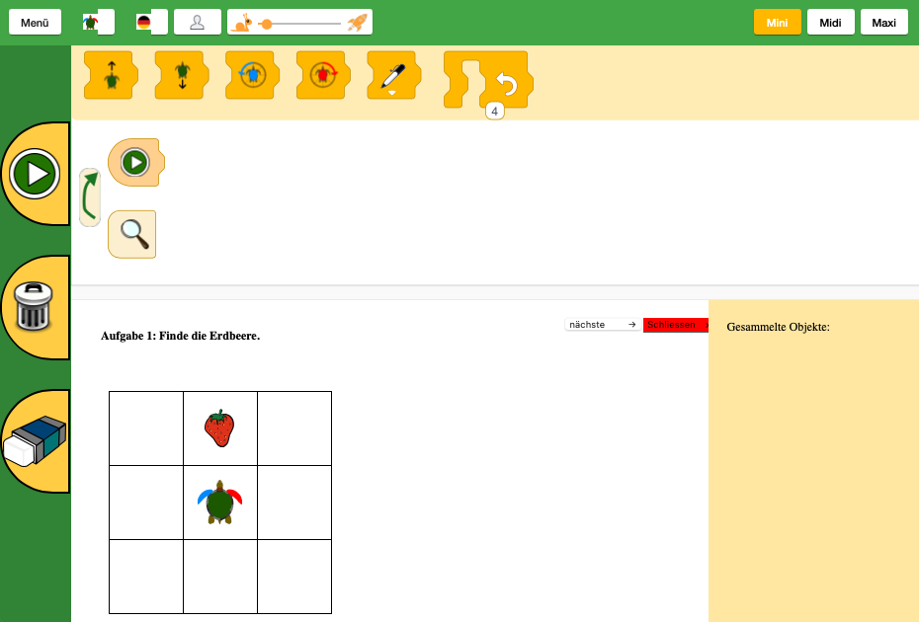Fig. 1: XlogoOnline (screenshot of user interface)

Kara
https://www.swisseduc.ch/informatik/karatojava/kara/

Kara is a ladybird who lives in a simple world. It can be programmed to do various tasks (e.g. collect clovers). Kara provides an introduction to the basic ideas of programming. In a playful way, the pupils make themselves familiar with fundamental ideas of programming.

The ladybird of Kara can be compared to the turtle of Logo. In order to move the ladybird, however, a finite automaton must be designed (graphically), i.e. a structure with a fixed set of possible objects, states and changes of state (actions). Finite automata are easy to understand, but very abstract for primary school students.

The programming environment Kara is a Java program; it has to be downloaded onto one's own computer and requires Java 6.

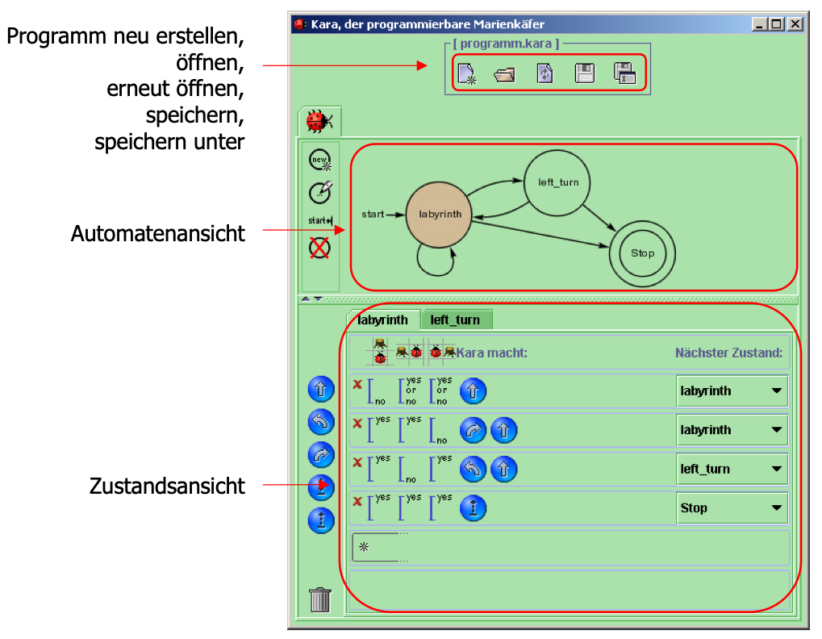Fig. 2: Kara (screenshot of user interface)

Scratch
https://scratch.mit.edu

Scratch is a programming environment with a simple graphical interface. Scratch promotes computational thinking (decomposition, pattern recognition, abstraction, algorithmic design), problem solving, creative teaching and learning as well as teamwork.

The US learning researcher Mitchel Resnick - a student of Seymour Papert - created Scratch together with a team of developers at the MIT Media Lab. Scratch is supported by the U.S. National Science Foundation and donations.

Scratch is not only suitable for programming with children. The Scratch programming environment is based on fundamental concepts of modern programming languages (object and event orientation, message exchange between objects = process communication). It can therefore be used equally well for more advanced computer science lessons.

Scratch is web-based; all you need to work with it is an active internet connection and a browser. However, a version of Scratch can also be installed and used locally (on MacOS, Windows, ChromeOS and Android - but not on iOS and iPadOS). In this case, a permanent internet connection is not necessary.

Scratch offers the possibility to publish one's own programs and to use and modify/extend (remix) published programs. So far, around 80 million programs have been published by Scratch users.

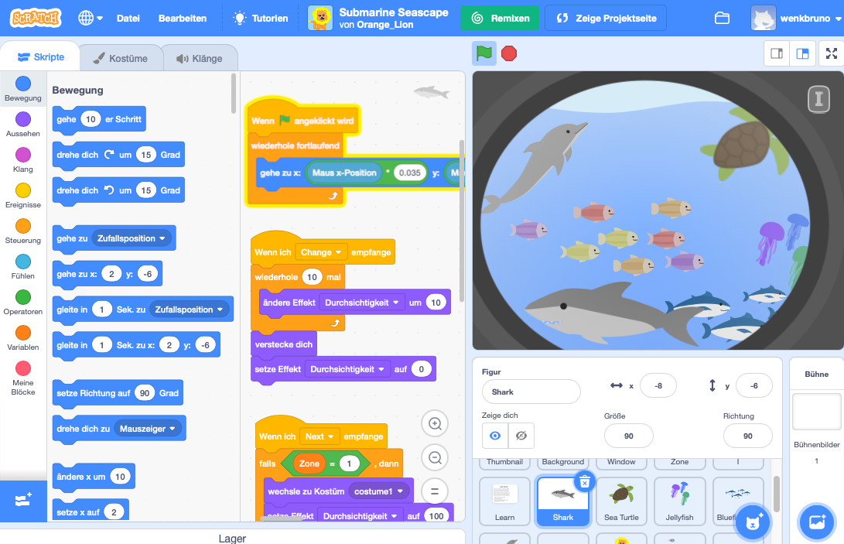Fig. 3: Scratch (screenshot of user interface)

Snap!
( https://snap.berkeley.edu )

Snap! is a kind of "Scratch++". The interface is based on Scratch. All Scratch components are also available (stage, characters = sprites, events, command symbols, etc.). However, Snap! offers a much wider range of functions for "professional" programming (the manual has more than 150 pages!).

Originally, Snap! was developed by Jens Möning as a "BYOB" ("Bring Your Own Beer" - invitation to a community activity) for adult education. In the meantime, the programming environment is published and maintained by the University of California, Berkeley. Snap! contains proprietary code in addition to open source parts.

Like Scratch, Snap! is suitable for programming with children. With its extended range of functions, Snap! is even more suitable than Scratch for in-depth computer science teaching.

Snap! is web-based; it simply requires an active internet connection and a browser. However, it is also possible to download the program to your own computer and use it locally without an internet connection (though not on tablets).

As with Scratch, Snap! also offers the possibility to publish one's own programs and to use and modify/extend (remix) published programs. However, there are only about 7000 published programs so far (2021).

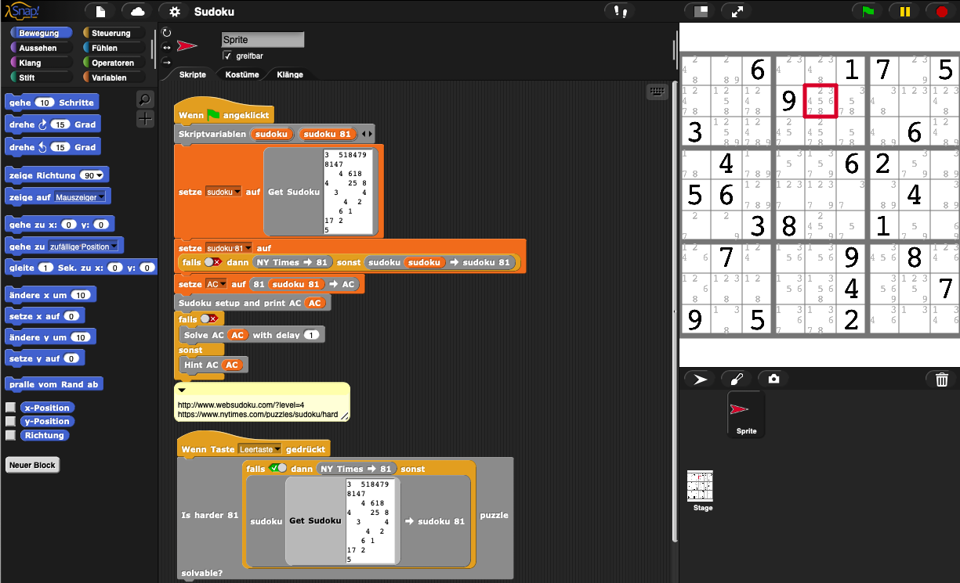Fig. 4: Snap! (screenshot of user interface)

ScratchKara
( http://www.boles.de/teaching/pkjava/solist/scratchkara.html )

ScratchKara was developed by Dr.-Ing. Dietrich Boles at the University of Oldenburg. ScratchKara is a combination of the two programming environments Scratch and Kara. One advantage of Scratch for beginners in programming is that no syntactical mistakes can be made and that small programs can be "clicked together" very quickly. For this reason, some ideas and concepts from Scratch are transferred to Kara in the so-called Scratch-Kara simulator.

The Scratch Kara Simulator must be downloaded onto one`s own computer and requires a Java Standard Edition Development Kit!
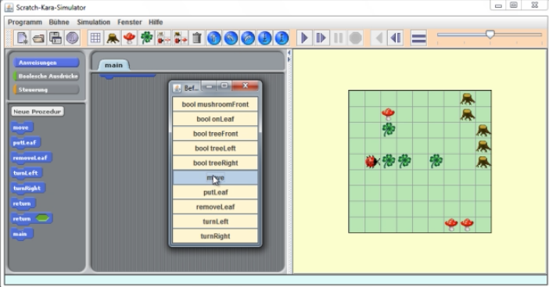Fig. 5: ScratchKara (screenshot of user interface)

WebTigerJython
( http://www.python-online.ch )

WebTigerJython is a student-friendly, web-based programming environment for the Python programming language. (Python is very popular; the programming language is well suited for computer science lessons in grammar school, but it is also used for software development in practice.) The WebTigerJython learning environment is especially designed for school lessons with the Swiss textbook "Einfach Informatik: Programmieren 7-9" (Klett und Balmer Verlag) by Juraj Hromkovič and Tobias Kohn, who teach at ETH Zurich and the University of Cambridge, respectively.

The programming is done in text form. A large number of modules support the programming of a wide variety of applications, including, for instance, turtle graphics, visualisation and simulation, micro:bit and Calliope mini. As a text-based programming environment, however, it is not considered for the programming course at an SSC-P.

WebTigerJython is web-based; an active internet connection and a browser are all you need to work with it.

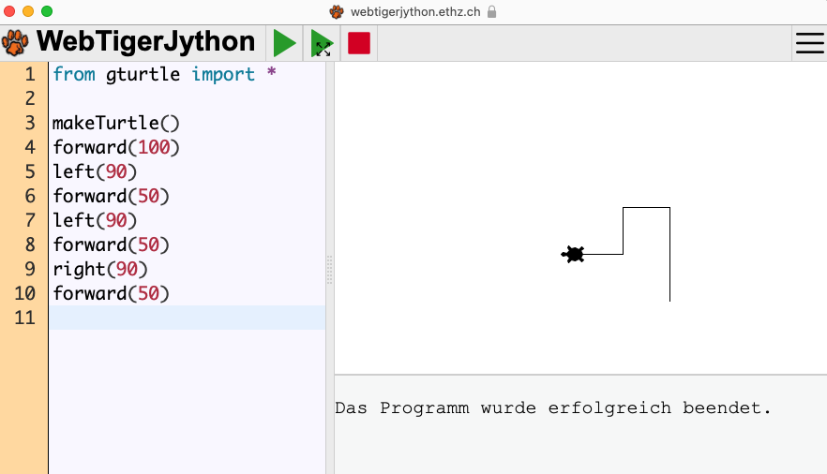Fig. 6: WebTigerJython (screenshot of user interface)

Selected programming environment: Scratch

The programming environment Scratch is very suitable for achieving the objectives of the programming course at ‹Specialised upper secondary schools - occupational field of education›.

With its support for modern programming concepts (object and event orientation, process communication), Scratch offers an environment that is generally suitable for programming at secondary schools.

Furthermore, Scratch is also specifically suitable for programming with children, especially for exploratory learning with turtle graphics.

Scratch was developed in 2007 and is now used in many schools at different levels. Scratch is free of charge and available in over 70 languages. The Scratch community comprises 42 million project creators. The Scratch Foundation, a non-profit organisation, ensures the long-term availability and further development of Scratch.

There is also a large selection of freely available teaching materials for Scratch. Scratch is web-based. Scratch users can therefore access their projects from any device with an internet connection (including tablets). Users can also exchange projects and further develop them together or individually (remix).

Those who want to use Scratch offline can install the programming environment locally on their own device. The app is available for MS Windows, macOS, ChromeOS and Android (Download-Page). There is no Scratch app for iOS and iPadOS (iPhone and iPad).

Structure of the programming course

The course is divided into four units.

Units 1 and 2 form a single lesson.

In unit 1, the students get to know the programming environment of Scratch and the basics of programming with the help of a sample project. They implement a matchstick puzzle (modelling). Without theoretical overload, they use basic concepts of object-oriented programming (objects, object properties, actions/methods, process communication). The students also make themselves familiar with a Scratch extension (text-to-speech).

Objectives unit 1

The students get to know the Scratch programming environment and how to use it to create and manage their own programming projects.
They learn the basic elements of the Scratch programming language and use them to "write" their first simple programs.
The students reflect on the experiences with programming.
They also learn (without too many theoretical considerations) basic concepts of "professional" programming (object and event orientation, process communication).

Unit 2 focuses on the concept of turtle graphics and the use of Scratch in primary school. Using the example of "properties of regular polygons", the students can experience exploratory learning with turtle graphics for themselves. In addition, the students learn about and apply the essential "basic building blocks" of programs (sequence, repetition, conditional execution, variables).

Objectives unit 2

The students get more familiar with Scratch.
They learn about and apply the "basic building blocks" of programs (sequence, repetition, conditional execution, variables).
The students understand the concept of turtle graphics for the exploratory learning in primary school.
They deal with the programming of turtle graphics by means of a concrete example.

Unit 3 is designed to introduce the students to the design and programming of multimedia stories / animations in Scratch.

Objectives unit 3

The students analyse a simple interactive, multimedia "story". They complete the "story" with an additional scene.
The students learn how to design and create "scenes" and "scene changes".
They learn how to design and implement animations.

In unit 4, the students deal with the simulation of a robotic lawnmower. They rely on the block concept, which makes their work much easier and provides a clearer outline of the program. Using this example, the students reflect on the problem of the determinacy and correctness of programmed solutions to problems.

Objectives unit 4

The students understand a simulation as a way of searching a solution for a problem.
They analyse and test the provided example of the simulation of a robotic lawnmower.
The students supplement the simulation example with an algorithm that they develop on their own.

They understand the block concept as a means to outline programs clearly.

External devices or systems (e.g. LEGO Mindstorm) were not taken into account. Such devices and systems are a matter of a robotics course.

"Data structures" are not sufficiently covered in this programming course. This is a shortcoming inherent in many instructions on how to learn programming. However, the given time budget of 8 lessons does not allow the topic of "data structures" to be dealt with adequately. It would make sense to discuss "data structures" in the context of social media. The students would then be able to recognise the importance and functioning of modern, networked data structures (linked data) and understand why companies are so interested in social media.

Teaching process

The students will bring different levels of prior knowledge to the course and show different levels of interest in programming. Some students will declare that they already know how to program. Others will be sceptical about whether they will ever learn it and whether they need it at all.

If the high expectations of programming in school (... logical and critical thinking, creativity, teamwork, ...) are to be fulfilled, the students must deal with the contents of the programming course in their own way.

There are instructions for each unit (student editions), with which the students can work independently in groups (ideally in pairs, if necessary in groups of three). This gives the teachers time to deal more intensively with the students who already have experience or are sceptical about programming. For this purpose, teachers have an accompanying document for each unit (teacher edition). Supporting the sceptical students in such a way that they experience their reservations as an encouragement, and motivating the experienced students to (self-)critically examine the contents of selected units would be desirable goals.

A formative evaluation of the learning outcomes does not make sense in this context. Conversely, a collaborative text editor (e.g. https://edupad.ch) would enable the students to continuously note down and discuss their questions / comments and reflections on the tasks . If necessary, the teacher might require all students to contribute at least three relevant questions and/or comments.

Time requirement

The time required for the four units is 2 lessons for each. Units 1 and 2 form a single lesson; depending on the class, they may take a little more time to complete. In that case, unit 4 might have to be omitted.

Material and sample solutions

The documents for the programming course (teacher edition, student edition) are freely accessible on the ZUM-Server (Zentrale für Unterrichtsmedien, https://unterrichten.zum.de/wiki/Programming_for_prospective_educators_(using_Scratch).

The templates and sample solutions to the tasks are published as projects on the Scratch platform in the studio "ITBO Programming" (https://scratch.mit.edu/studios/33643766/).

Kafai, Yasmin B.; Burke, Quinn (2014): Connected Code - Why Children Need to Learn Programming. MIT Press.
Kronk, Henry (2019): Seymour Papert LOGO Turtles, and the origin of educational robots. https://news.elearninginside.com/seymour-papert-logo-turtles-and-the-origin-of-educational-robots/

